VMware IT Academy Registration Instructions.

You will be enrolled in the VMware Academy shortly. After enrolment, you will receive an activation email that looks something like the screen capture below. It is not a phishing email.

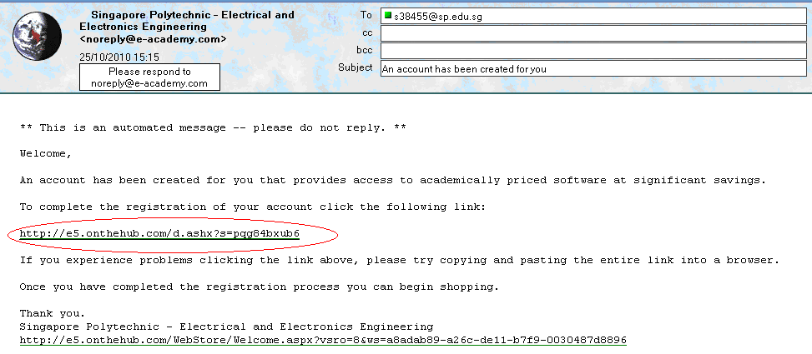

Please click the link circled in red to complete registration. This will take you to the VMware site. The VMware site will look like the screencap below. Fill in the fields circled in red, then click submit.

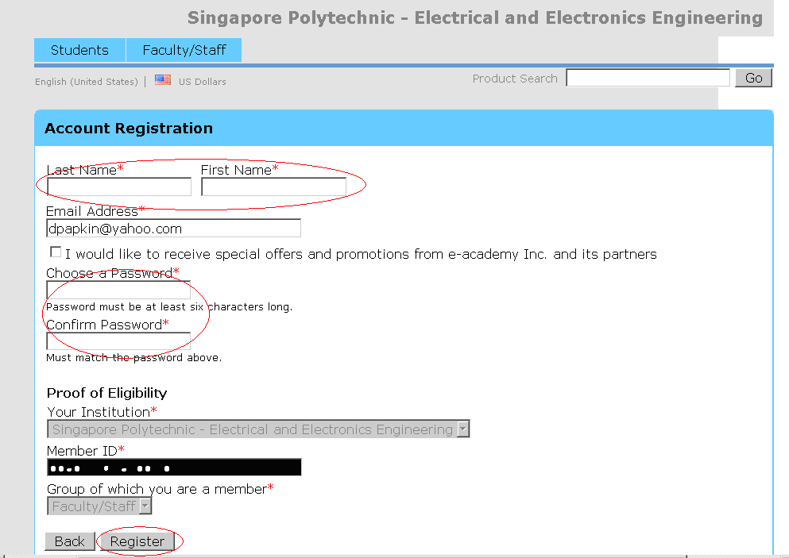

After registration is complete, you can check out any software listed on the web page. Just click on the software you would like to download and add it to the cart and then checkout.

